VENANGO TECHNOLOGY CENTER
JOINT COMMITTEE
1 Vo-Tech Drive
Oil City, Pennsylvania 16301

MINUTES

April 5, 2021

The regular meeting of the Venango Technology Center Joint Committee was held this evening in the Conference Room of the Venango Technology Center, 1 Vo-Tech Drive, Oil City, PA 16301. Mr. Come called the meeting to order at seven o’clock (7:00) p.m.

Mr. Come asked the members to pause for a moment of silence.

Mr. Come asked the members to stand for the pledge of allegiance.

Roll Call: Present: Todd Carson, Robert Blauser, Andy Boland, Troy Johnston, Shari Neely,
James Come (zoom)

Absent: Mark Marterella, Jeff Thomas, James Disque, Don Judy

Also Present: Mr. Mario Fontanazza, Mrs. Stephanie Keebler (zoom)

Mr. Come stated the Joint Committee members had received copies of the Minutes of the March 1, 2021 meeting in the mail. He asked if there were any additions, corrections or deletions.

Mr. Carson, seconded by Mr. Blauser, moved to approve the Minutes of the March 1, 2021 meeting as submitted.

Roll Call: Ayes: Todd Carson, Robert Blauser, Andy Boland, Troy Johnston, Shari Neely,
James Come

Nayes: None, motion carried.

The Treasurer and Secretary’s Report as of 4/5/21 were submitted for information.

Mr. Carson, seconded by Mr. Blauser, moved to accept the Treasurer and Secretary’s Report as of 4/5/21 as submitted.

The motion was unanimously approved.

A list of bills from 3/2/21 – 4/5/21 in the amount of $948,665.42 was presented for approval.

Mrs. Keebler questioned the LPN student refunds and Mr. Adams explained this was PA TIP funds.

Mr. Blauser, seconded by Mr. Carson, moved to approve the list of bills as presented.

Roll Call: Ayes: Todd Carson, Robert Blauser, Andy Boland, Troy Johnston, Shari Neely,
James Come

Nayes: None, motion carried.

Under Communications, Mr. Fontanazza discussed the Professional Advisory Committee. He also discussed the Calendar of Events for the month of March and the Monthly Enrollment Report as of 4/5/21 were submitted.

Mr. Come requested approval of the action items as presented. Item 8. a) i.- ix. in one motion.

Mr. Carson, seconded by Mrs. Neely, moved to approve action items i.- ix. as follows:

- Approve contract for Financial software application modules and Student accounting
modules for the CSIU software packages for the 2021-2022 school year.
- Approve 2-year contract with Tri-County Industries for waste removal at 654.07 per month.
- Adopt a resolution authorizing Mario Fontanazza to sign all contracts with the PA
Department of Education and that those signatures be electronic.
- Approve Linda Lander and two Coop students as summer maintenance helpers.
- Approve Anthony Pierucci as Automotive Technology instructor at step 1, column A of the collective bargaining agreement beginning with the 2021-2022 school year.
- Approve advertising for the Adult Education/Apprenticeship coordinator requiring principal certification for 240 days at a starting salary of $70,000.00 and an Act 93 agreement.
- Approve equipment list for disposal.
- Approve four-day summer work week schedule for all 12-month staff.
- Approve Melissa Farneth as a bus driver for Forest Area.

Roll Call: Ayes: Todd Carson, Robert Blauser, Andy Boland, Troy Johnston, Shari Neely,
James Come

Nayes: None, motion carried.

Mr. Fontanazza reviewed his Issues/Activities for March 2021.

Mr. Adams mentioned that revisions to Board Policies were located on the website and on review until the May 2021 meeting at which time they will be up for approval.

Mr. Come asked if there was any old business.

None was noted.

Mr. Come asked if there was any new business.

None was noted.

Upon motion by Mr. Johnston, seconded by Mr. Carson, the meeting adjourned at twenty minutes past seven (7:20) p.m.

Recorded by
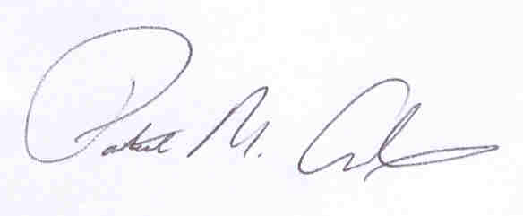
Patrick M. Adams
Secretary, Joint Committee

